1. Biaya cat rony(Pajero rockford, xenia 2012, 2020, wrangler sport)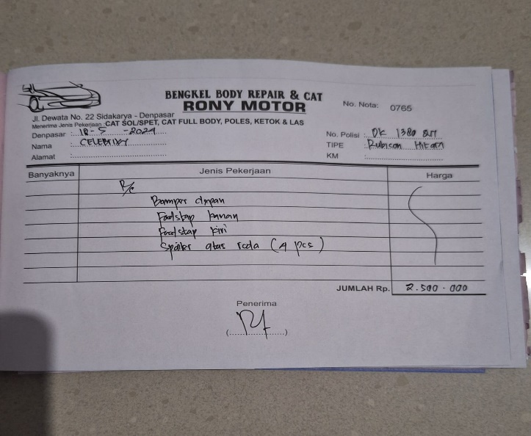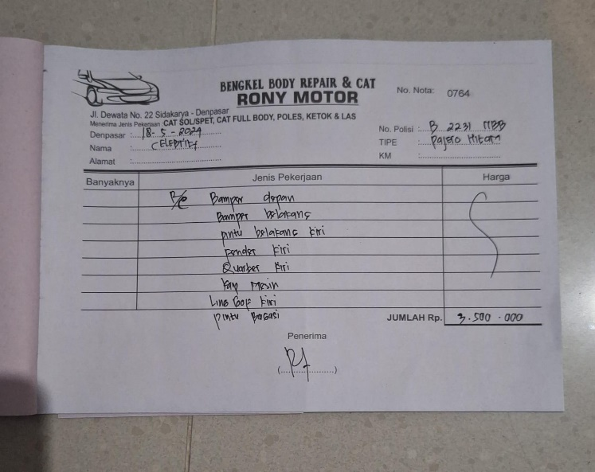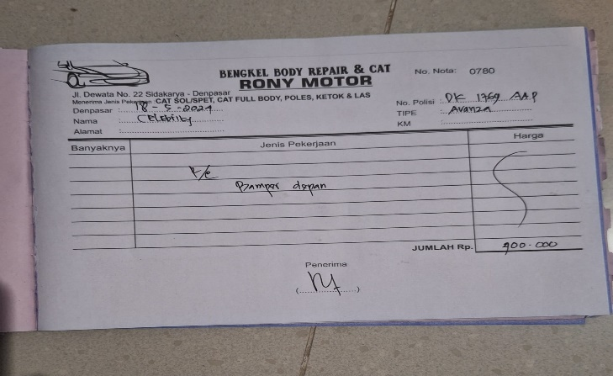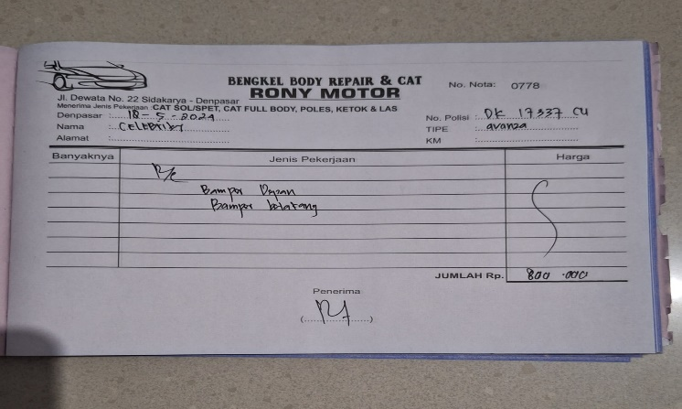
2. Biaya auto family(cover ban serep & jok sopir)

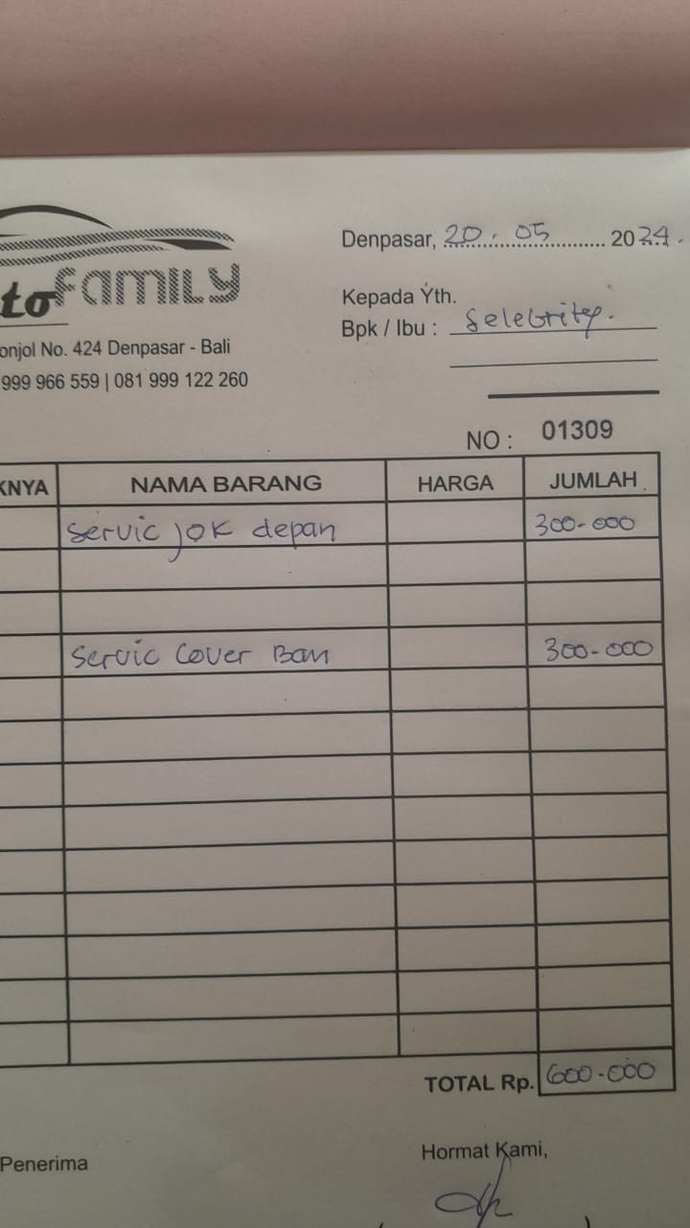

1. 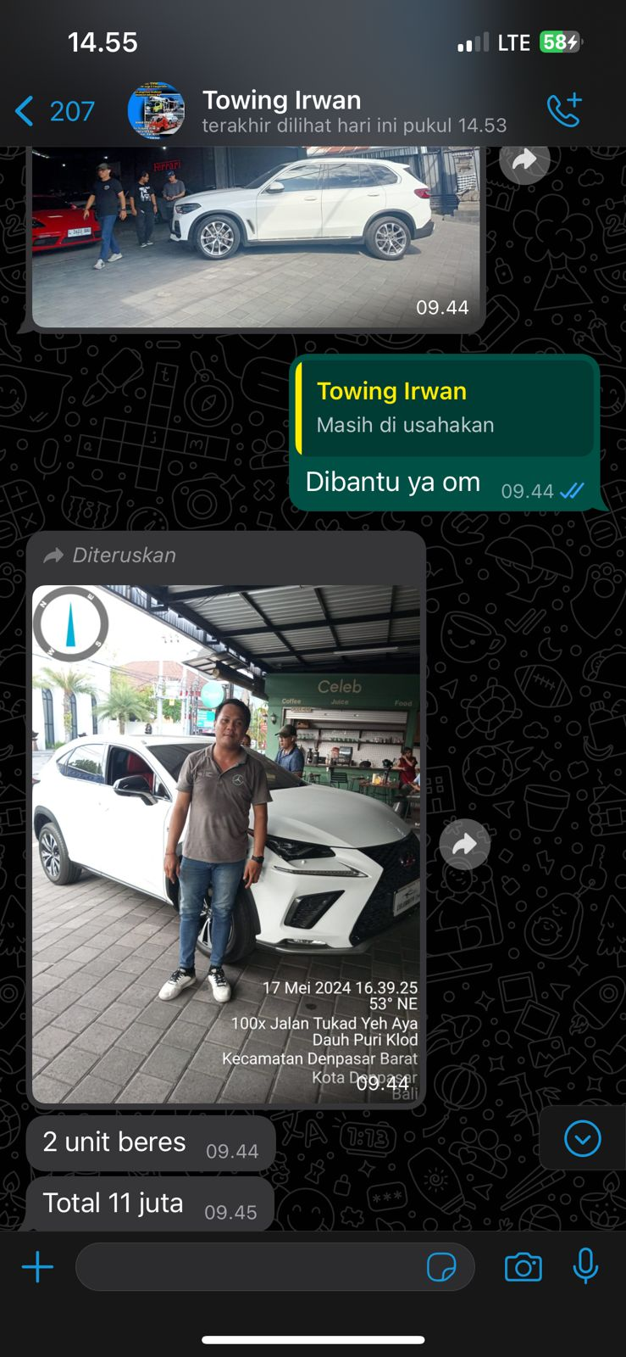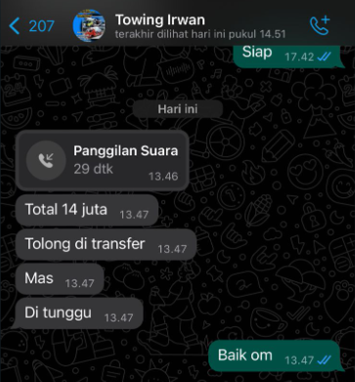Towing 3 mobil (x5, nx, palisade)
2. 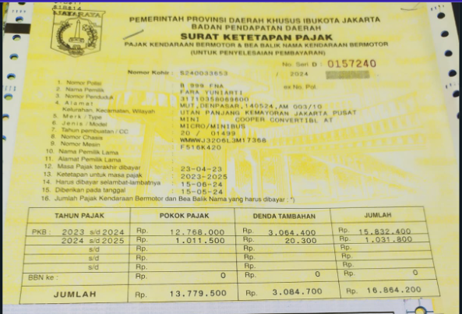Skp pajak mini cabrio putih fna
3. Cat Ferrari kuning (via telfon)
4. 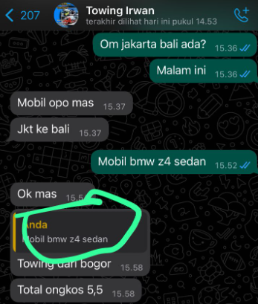Towing bmw z4
5. Lampu belakang xenia 2012 (via telfon)
6. Nopol tuaji bmw x5 dan gle

